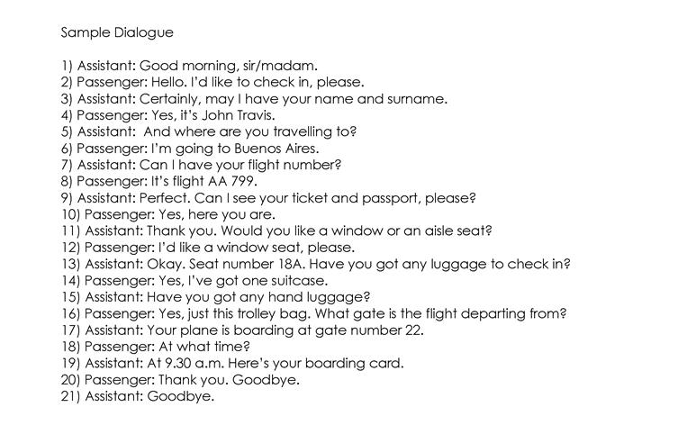

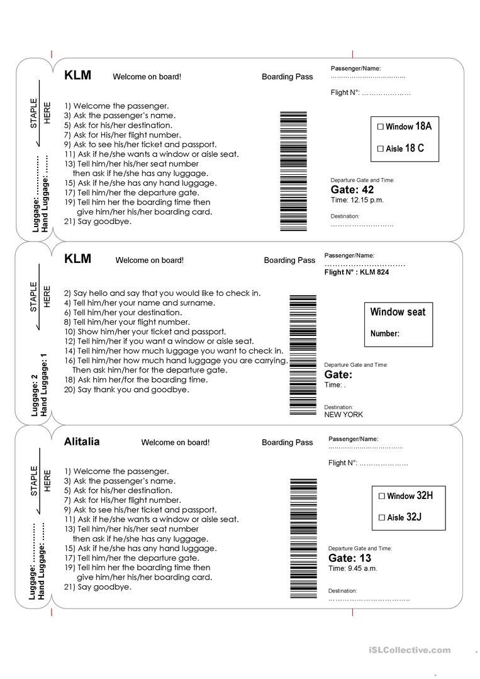
THANKS TO:
https://en.islcollective.com/english-esl-worksheets/vocabulary/travel/airport-role-play/76711

