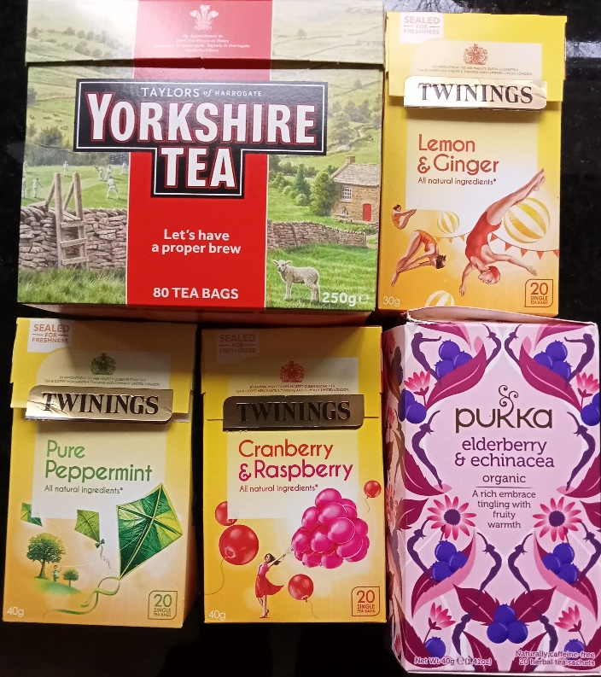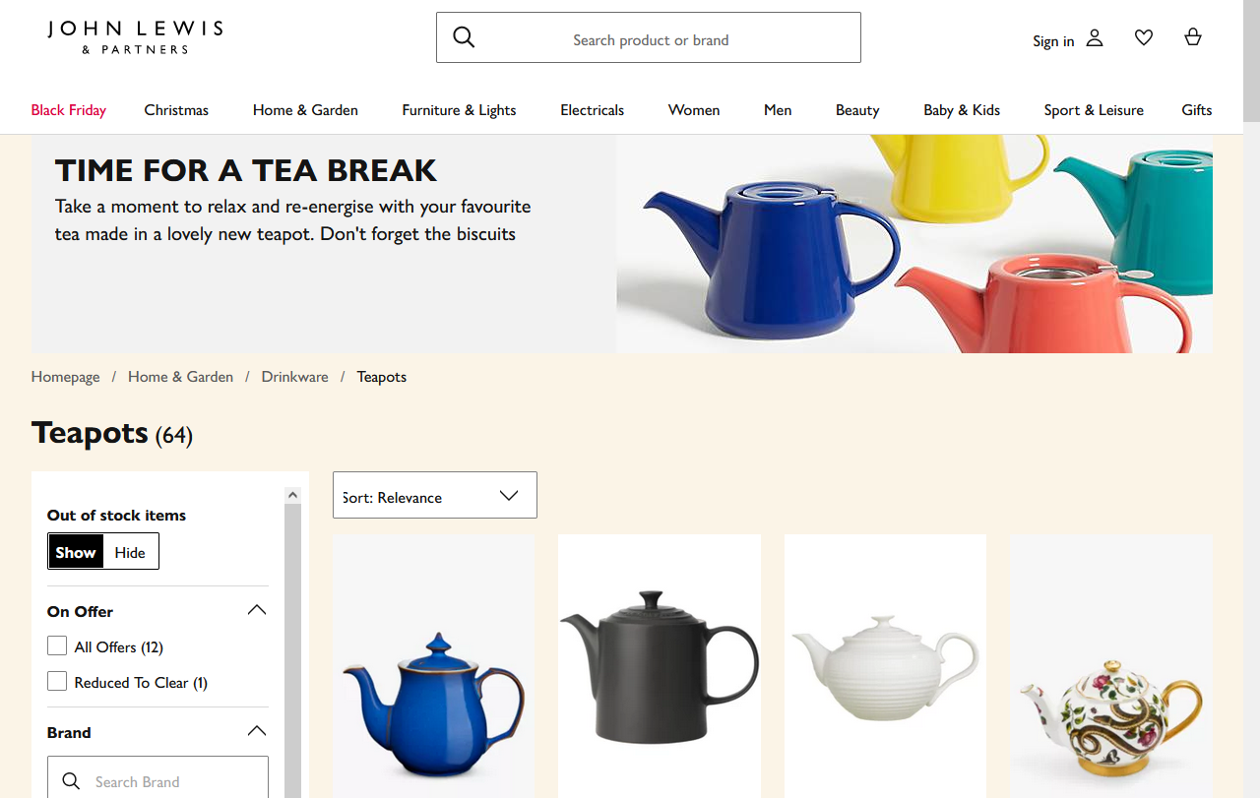
Tea Bags or Tea-Pot?
Yorkshire Tea; English Breakfast Tea
Earl Grey
Herbal Tea
Green Tea
Milk? Sugar?

